React Hands-on 1: Create a New React Application

Commands
npx create-react-app myfirstreact
cd myfirstreact
code .
npm start
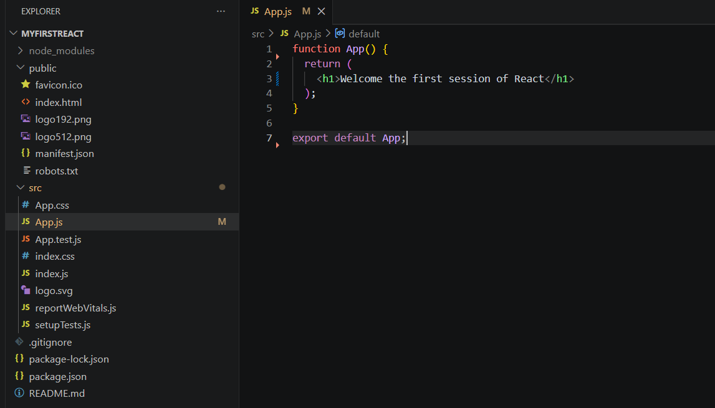

App.js
function App() {
return (
<h1>Welcome the first session of React</h1>
);
}
export default App;
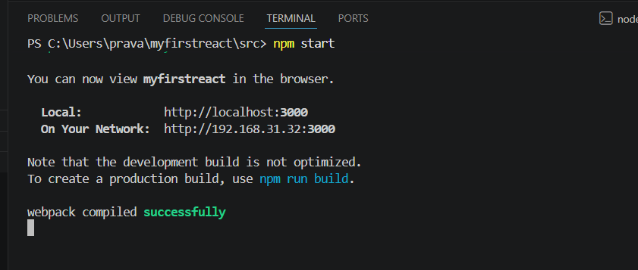

Expected Output
Welcome the first session of React
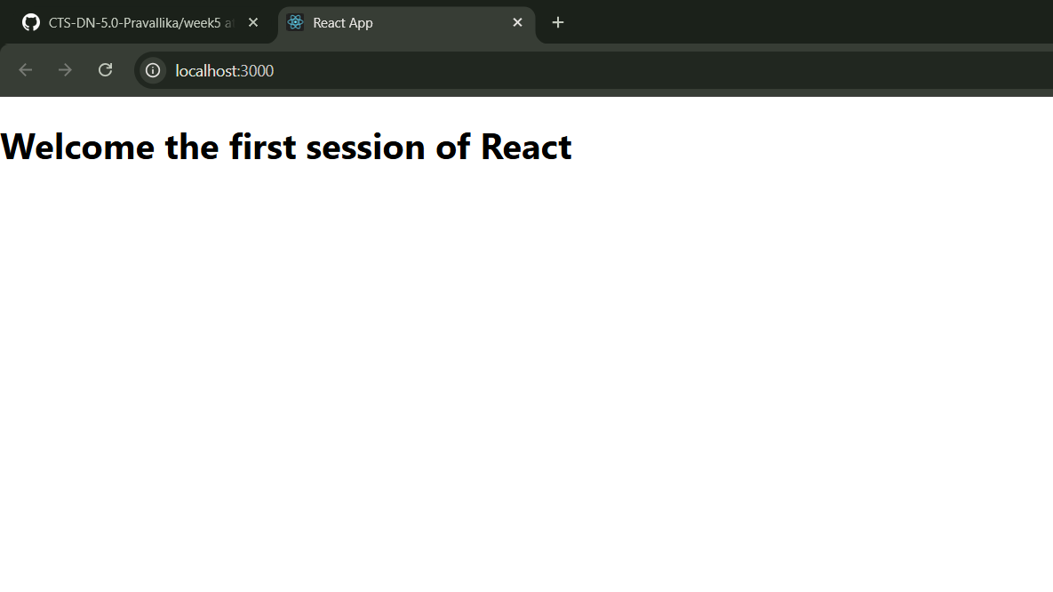

Result
The React application was created successfully and the required output was displayed in the browser.

